Remote deposit capture
Northeast nebraska
Federal Credit Union
Fall 2025 Newsletter

Did you know you can deposit checks to your account from anywhere? Using the NNFCU mobile app, you take a picture of the check you want to deposit and submit it electronically. Pending approval, the deposit will be posted by the next business day. Remote deposit is a quick, convenient way to deposit checks into your account. Call for more information!
ONLine & MOBILE Banking
Even though our hours have changed we have options for you 24/7. We still have our night drop in the front of our building, but you can also use our mobile banking to deposit a check in your account immediately. Looking to withdrawal cash? Go to our website to find a free ATM from any town in the US. There is so much more! Call for more information or to get started today!

International Credit Union day

Come help us celebrate International Credit Union Day on Thursday, October 16, 2025! We will have refreshments in our lobby for our members to enjoy. Stop in that day to get your 2026 calendar!
  - FRAUDULENT SCAMS
With everything going on in the world today we want our members to know we are here to help protect you! We have already seen so much fraud! Scams are everywhere and we know there are many more schemes to come! Be cautious of phone calls, do not give out your personal information. Be careful and make sure you are on the correct website. Watch out for Crypto or Bitcoin Schemes. Be cautious of people you meet online, if they want you to wire them money, send you money and in return you send them gift cards, etc., DO NOT DO IT. If you have not met them in person beware, once the money is sent it is gone. DO NOT LISTEN TO THOSE FRAUDSTERS! Tell us all about it. If they want you to hide information from your Financial Institution, chances are it is ILLEGAL! So please ask questions or if there is any doubt, please feel free to run it past one of us at the CU, we may have heard about a new scam. We are here for you and have your best interest in mind!
  - FRAUD ALERTS
Suspicious activity or accounts you do not recognize can be signs of identity theft. People with good credit should check their credit reports too. Regular checks ensure the information stays accurate. Your good credit will be ready when you need it. www.AnnualCreditReport.com is the only official site explicitly directed by Federal law to provide FREE reports. With the recent fraud scares, you should go to www.AnnualCreditReport.com and check your credit report with 1 of the 3 bureaus as you get 1 FREE report from each bureau every 12 months! Contact the Credit Union with any questions.
The Credit Union Will be closed:
- OCTOBER 13, 2025 IN OBSERVANCE OF cOLUMBUS DAY
- NOVEMBER 11, 2025 IN OBSERVANCE OF VETERAN’S DAY
- NOVEMBER 27 & 28, 2025 IN OBSERVANCE OF THANKSGIVING
- DECEMBER 24, 2025 CLOSE AT 12 PM IN OBSERVANCE OF CHRISTMAS EVE
- DECEMBER 25 & 26, 2025 IN OBSERVANCE OF CHRISTMAS
- DECEMBER 31, 2025 CLOSE AT 12 PM IN OBSERVANCE OF NEW YEAR’S EVE
- JANUARY 1, 2026 IN OBSERVANCE OF NEW YEAR’S DAY

WE WOULD LIKE TO WISH EVERY ONE OF OUR MEMBER’S A HAPPY HOLIDAYS!!!!! WE HOPE EVERYONE HAS A SAFE HOLIDAY SEASON!!!!!

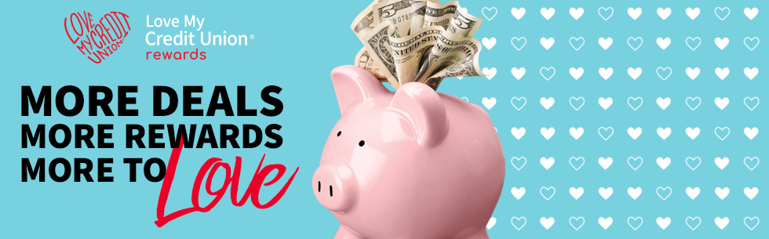

There are more reasons than ever to love being a member of
NORTHEAST NEBRASKA FEDERAL CREDIT UNION.
Your credit union membership is about the trust and care of community, built around where you live, work and play. That’s why credit union membership saves you money through exclusive member-only offers through our trusted partners. Through Love My Credit Union Rewards, credit union members have saved over $2 billion with offers like these.
» Trust & Will: Members get exclusive savings of 20% off any estate plan with Trust & Will.
» TurboTax: Get a bigger discount this tax season with savings of up to 20% on TurboTax federal products.
» H&R Block: Members can save up to $25 on in-office tax prep at H&R Block.
» TruStage Home & Auto Insurance Program: Get exclusive member pricing and a FREE, no-obligation quote by calling 800-789-6286.
» Rental Kharma: Build your credit history with rent and save up to 30% on Rental Kharma.
Learn all about how your NNFCU membership gets you all these exclusive savings and more at LoveMyCreditUnion.org. Check them out and start enjoying credit union member benefits you never knew you had.

Mobile Banking App

Login into your account at www.nnfcu.com to set up the easy-to-use Mobile Banking App! Once set up is complete you will have access to your account right at your fingertips. Call the Credit Union for more details or if you have any questions.

Northeast nebraska federal credit union
Owned and operated by our membErs for our members
1306 North 13th Street Suite 102
Norfolk Ne 68701
(402) 371-9345 www.nnfcu.com

