ONLine & MOBILE Banking
Northeast nebraska
Federal Credit Union
Fall 2021 Newsletter

There have been some changes to the way you logon to online banking. For the security of our members account information, we now require everyone to create a username and password instead of using your account number to log into your account. Please WRITE THIS INFORMATION DOWN as it will ask you this every time you logon, and remember it is case sensitive! Also, be watching in the near future for the look of our online and mobile banking to change! It will be mobile friendly with more features and easier to use for all our members!

International Credit Union day

Come help us celebrate International Credit Union Day on Thursday, October 21, 2021! We will have refreshments in our lobby for our members to enjoy, COVID permitting otherwise we will have goodies to handout through our Drive Thru. Come through the drive thru to get your 2022 calendar if they arrive in time!
  - FRAUDULENT SCAMS
With everything going on in the world today we want our members to know we are here to help protect you! We have already seen so much fraud surrounding COVID-19, as well as the previous scams and we know there are many more schemes to come! Be cautious of phone calls, do not give out your personal information. Be cautious of people you meet online, if they want you to wire them money, send you money and in return you send them gift cards, etc., DO NOT DO IT. If you have not met them in person beware, once the money is sent it is gone. DO NOT LISTEN TO THOSE FRAUDSTERS! Tell us all about it. If they want you to hide information from your Financial Institution, chances are it is ILLEGAL! So please ask questions or if there is any doubt please feel free to run it past one of us at the CU, we may have heard about a new scam. We are here for you and have your best interest in mind!
  - FRAUD ALERTS
Suspicious activity or accounts you do not recognize can be signs of identity theft. People with good credit should check their credit reports too. Regular checks ensure the information stays accurate. Your good credit will be ready when you need it. www.AnnualCreditReport.com is the only official site explicitly directed by Federal law to provide FREE reports. With the recent fraud scares, you should go to www.AnnualCreditReport.com and check your credit report with 1 of the 3 bureaus as you get 1 FREE report from each bureau every 12 months! Contact the Credit Union with any questions.
The Credit Union Will be closed:
- OCTOBER 11, 2021 IN OBSERVANCE OF cOLUMBUS DAY
- NOVEMBER 11, 2021 IN OBSERVANCE OF VETERAN’S DAY
- NOVEMBER 25 & 26, 2021 IN OBSERVANCE OF THANKSGIVING
- DECEMBER 24 & 25, 2021 IN OBSERVANCE OF CHRISTMAS
- DECEMBER 31, 2021 CLOSE EARLY IN OBSERVANCE OF NEW YEAR’S EVE
- JANUARY 1, 2022 IN OBSERVANCE OF NEW YEAR’S DAY

WE WOULD LIKE TO WISH EVERY ONE OF OUR MEMBER’S A HAPPY HOLIDAYS!!!!! WE HOPE EVERYONE HAS A SAFE HOLIDAY SEASON!!!!!

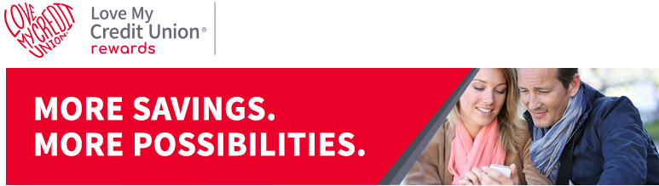

There are more reasons than ever to love being a member of NORTHEAST NEBRASKA FEDERAL CREDIT UNION.
Your credit union membership is about the trust and care of community, built around where you live, work and play. That’s why NNFCU membership saves you money through exclusive member-only offers through our trusted partners. Through Love My Credit Union Rewards, credit union members have saved over $2 billion with offers like:
» Members can save up to $360 on their wireless bill by switching to no-contract wireless.
» Members can save up to 35% on IdentityIQ credit report monitoring and identity theft protection.
» Savings up to $15 on TurboTax federal products.
» Exclusive access to home tech support and protection with Asurion Home+.
» Exclusive discount from the TruStage Home & Auto Insurance Program.
» Members save on SimpliSafe, the #1 expert pick for home security.
» Exclusive access to the Love My Credit Union Rewards Powersports, RV & Boat Buying Program.
» Save on car maintenance + get $10 off your first service using CarAdvise.
» Save 40% on a 1-year membership to Sam's Club.
» Build your credit history with rent and save up to 30% with Rental Kharma.
» Save $40 on Calm, the #1 app for meditation and sleep.
» Save on your Travel and Entertainment needs like Car Rentals, Hotels, Theme Parks, Movie Tickets and more!
Learn all about how your NNFCU membership gets you all these exclusive savings and more at LoveMyCreditUnion.org. Check them out and start enjoying credit union member benefits you never knew you had.
Mobile Banking App

Login in to your account at www.nnfcu.com to set up the easy to use Mobile Banking App! Once set up is complete you will have access to your account right at your fingertips. Call the Credit Union for more details or if you have any questions.

Northeast nebraska federal credit union
Owned and operated by our membErs for our members
1306 North 13th Street Suite 102
Norfolk Ne 68701
(402) 371-9345 www.nnfcu.com

