Northeast nebraska
Federal Credit Union
Summer 2018 Newsletter

  - BOARD OF DIRECTORS SEEKING VOLUNTEERS
The Board of Directors is actively seeking a volunteer! We are still trying to find ONE more member to join the Supervisory Committee. For more details please contact any Board of Director or the Credit Union. We need to fill this vacancy IMMEDIATELY!!!!!

NNFCU wants to know
  - Northeast Nebraska Federal Credit Union wants to know what our members want!!!! Please, call, email or stop in to let us know what you want out of YOUR Credit Union. Are there services other Financial Institutions offer that you would like to see NNFCU offer? Just let us know!
[Type a quote from the document or the summary of an interesting point. You can position the text box anywhere in the document.]

beSt Rates in norfolk

Looking for those Summer toys? Needing some extra cash for vacation? Starting to shop for school vehicles? Don’t forget to check us out for those lending needs. Vehicles starting as low as 2.99% APR* or Boats, Campers, ATVs starting as low as 3.99% APR* or Personal Loans starting as low as 6.99% APR*. Stop in to see Lindsey for all your lending needs!
*Annual Percentage Rate *With approved credit
*Some restrictions Apply *Rates may change at any time
  - FIRST MORTGAGES OR HOME EQUITY LOANS
Looking for a new home or to remodel your existing home, make sure you give Dave Olson from 1st Mortgages a call. Dave is there to find you the best option to get you into your dream home! Go to our website and click on the link to 1st Mortgages to fill out an application or give Dave a call at (402)881-5951 or email at DOlson@1stMtgs.com

THAnK YOU
  - We want to take this opportunity to say Thank you!!!! Thank you to our members for you continued business with NNFCU!!!! Continue to spread the word to your friends and family about NNFCU!!!!!
The Credit Union Will be closed:
- JULY 4, 2018 IN OBSERVANCE OF INDEPENDENCE DAY
- SEPTEMBER 3, 2018 IN OBSERVANCE OF LABOR DAY
- OCTOBER 8, 2018 IN OBSERVANCE OF COLUMBUS DAY

[Type a quote from the document or the summary of an interesting point. You can position the text box anywhere in the document.]

The benefits of membership have never been better with Northeast Nebraska Federal Credit Union.
Saving on the products and services you want, and need has never been easier. Your Northeast Nebraska Federal Credit Union membership can help you save money today with exclusive discounts and benefits from trusted partners. Members have saved nearly $2 billion with great offers, such as:
- Get a $100 cash reward for each new line you activate, up to 3 lines. Plus, get a $50 cash reward every year for as long as you are a Sprint customer. *
- Up to $15 off TurboTax® federal products!
- An exclusive smoke communicator and a $100 gift card with a new ADT® monitored home security system. You must call 844-703-0123 to receive this special offer through the Love My Credit Union® Rewards Program.
- Trusted protection at true savings with the TruStage® Auto & Home Insurance Program.
- Cash back at over 1,500 online retailers with Love to Shop.

Learn more about these and other valuable discounts at nnfcu.com or LoveMyCreditUnion.org,
and start enjoying yet another benefit of being a valued Northeast Nebraska Federal Credit Union member.
E-STATEMENT AND NEW ACCOUNTS

Sign up for e-statements and received a gift from NNFCU
Bring in your kids or grandkids to open an account and they will receive a “cool” treat for the summer!
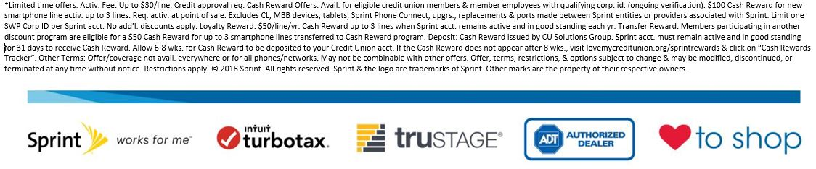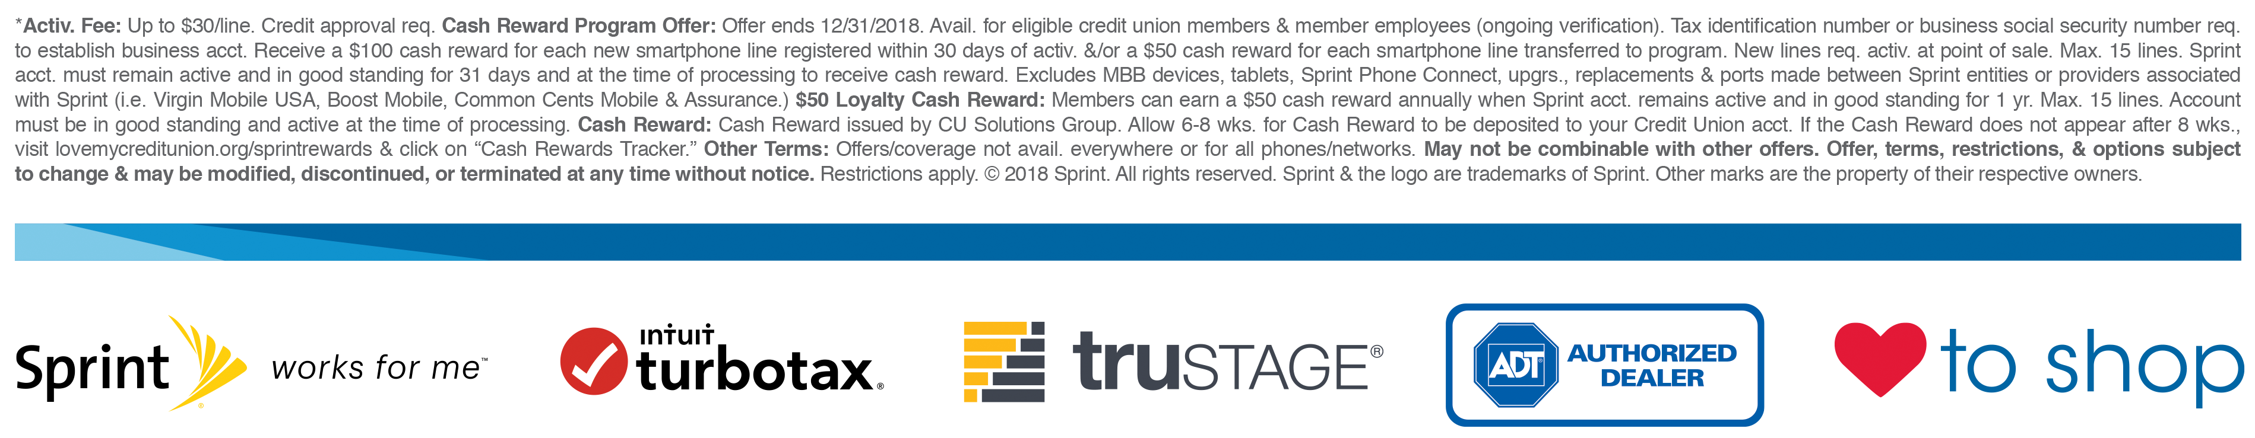
Northeast nebraska federal credit union
Owned and operated by our membErs for our members
1306 North 13th Street Suite 102
Norfolk Ne 68701
(402) 371-9345 www.nnfcu.com

