Northeast nebraska
Federal Credit Union
Spring 2018 Newsletter

  - BOARD OF DIRECTORS SEEKING VOLUNTEERS
The Board of Directors is actively seeking volunteers! We are still trying to find two more members to join the Supervisory Committee and the Board of Directors. For more details please contact any Board of Director or the Credit Union. We need to fill these vacancies IMMEDIATELY!!!!!

Shred Day
  - Northeast Nebraska Federal Credit Union is trying something new this year! Our annual Shred day is in the SPRING! Get some spring cleaning done and come join us on Saturday, April 21, 2018 from 9 am – 12 pm here at the Credit Union parking lot. There is a limit of 4 totes per member. Going to be out of town that Saturday for the Husker Spring Game? No worries we will accommodate you! Bring it in on Friday, and we will keep it safe until Saturday morning! Come join us for a morning of food, giveaways and prizes!!!!
[Type a quote from the document or the summary of an interesting point. You can position the text box anywhere in the document.]

Spring Loan Promotion

Need some extra cash to spruce up your yard this spring? NNFCU is offering a Spring Loan Promotion starting as low as 5.99% APR for as much as $2000. Looking for those Summer toys? Don’t forget to check us out for those lending needs. Boats, Campers, ATVs starting as low as 3.99% APR. Stop in to see Lindsey for all your lending needs!
  - FIRST MORTGAGES OR HOME EQUITY LOANS
Looking for a new home or to remodeling your existing home, make sure you give Dave Olson from 1st Mortgages a call. Dave is there to find you the best option to get you into your dream home! Go to our website and click on the link to 1st Mortgages to fill out an application or give Dave a call at (402)881-5951 or email at DOlson@1stMtgs.com

Credit union rewards program
  - Go to www.lovemycreditunion.org or click on the link at the Credit Union’s website to see all the rewards out there for credit union members. If you haven’t already, create an account and start saving at over 1,500 Retailers!
[Type a quote from the document or the summary of an interesting point. You can position the text box anywhere in the document.]

The Credit Union Will be closed:
- may 28, 2018 IN OBSERVANCE OF memorial Day
- JULY 4, 2018 IN OBSERVANCE OF INDEPENDENCE DAY
More money in your pocket, thanks to Northeast Nebraska Federal Credit Union and Love My Credit Union® Rewards.
Saving on the products and services you need and use every day is easy with Love My Credit Union Rewards. As a
member of Northeast Nebraska Federal Credit Union, you can get discounts and rewards that include:
» A $100 cash reward with every new line activated with Sprint®! Current customers will receive a $50 cash
reward for every line transferred into Sprint® Credit Union Member Cash Rewards. Plus, get a $50 loyalty
cash reward every year for every line.* And there’s more! Members are eligible for 25% off accessories.
» Up to $15 off TurboTax® federal products!
» An exclusive smoke communicator and a $100 gift card with a new ADT® monitored home security system. You must call 844-703-0123 to receive this special offer through the Love My Credit Union Rewards Program.
» Trusted protection at true savings with the TruStage® Auto & Home Insurance Program.
» Cash back at over 1,500 online retailers with Love to Shop.
Sign up now and join the credit union members who have saved nearly $2 billion in discounts.
Visit www.nnfcu.com or LoveMyCreditUnion.org today!
NEW WEBSITE COMING SOON

Watch for our new website to come out the beginning of 2018! It should be easier to navigate and find all the great products and services NNFCU offers our members! You will still be able to access it at
www.nnfcu.com
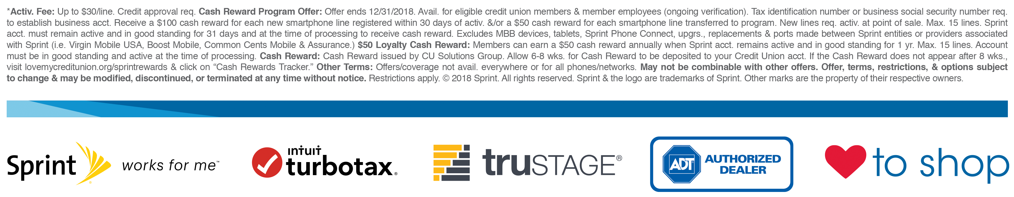
Northeast nebraska federal credit union
Owned and operated by our membErs for our members
1306 North 13th Street Suite 102
Norfolk Ne 68701
(402) 371-9345 www.nnfcu.com

