Northeast nebraska
Federal Credit Union
Winter 2019 Newsletter

  - BOARD OF DIRECTORS SEEKING VOLUNTEERS
The Board of Directors is actively seeking volunteers! We are still trying to find two more members to join the Supervisory Committee. For more details please contact any Board of Director or the Credit Union. We need to fill these vacancies IMMEDIATELY!!!!!

Annual Meeting
  - Northeast Nebraska Federal Credit Union will be holding our 57th Annual Meeting on Saturday, March 23, 2019. Again, this year it will be held at the VFW in Norfolk with social hour starting at 5:30 pm and dinner at 6 pm. Watch for more details regarding the meal and ticket prices at the Credit Union. Come join us for a night of food, fun and prizes!!!!
[Type a quote from the document or the summary of an interesting point. You can position the text box anywhere in the document.]
  - TAX SEASON
As tax season is rapidly approaching, do not forget that there are discounts for Credit Union Members! Go to lovemycreditunion.org, click on the Turbo Tax link, pick Nebraska, pick Northeast Nebraska Federal Credit Union, and find the Turbo Tax Product that best fits you! Remember if you sign up for direct deposit the Credit Union’s routing number is 304982772.

sHRED DAY
  - Northeast Nebraska Federal Credit Union will be having our annual Shred Day in the Spring again! Shred Day will be held on April 27, 2019 from 9am to 12pm here at the Credit Union parking lot. Bring your documents you need shredded and enjoy some refreshments!
[Type a quote from the document or the summary of an interesting point. You can position the text box anywhere in the document.]

  - THIRD QUARTER DIVIDEND POSTING ERROR
We apologize for the dividend posting error. You will see on your September Statement a dividend posting, and then in October the statement shows the dividend backed off and a smaller amount posted. This was due to NNFCU raising our rates effective September 1, 2018 and the data processor calculated the higher rate for the entire quarter. Sorry for any confusion.
The Credit Union Will be closed:
- January 1, 2019 IN OBSERVANCE OF New year’s Day
- JANUARY 21, 2019 IN OBSERVANCE OF MARTIN LUTHER KING, JR. DAY
- FEBRAURY 18, 2019 IN OBSERVANCE OF PRESIDENTS’ DAY

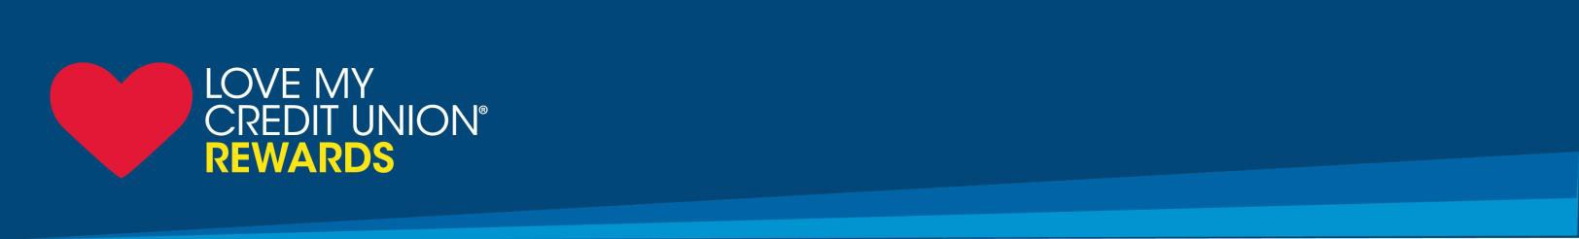
Northeast Nebraska Federal Credit Union Members Get Cash Rewards, Deep Discounts and Exclusive Savings.
Credit union members have saved nearly $2 billion with Love My Credit Union Rewards discounts! The more offers you take advantage of, the more you save.

- Get a $100 cash reward for each new line you activate, up to 3 lines. Plus, get a $50 cash reward every year for as long as you are a Sprint customer.*
- Save up to $15 on TurboTax Federal online and downloadable tax products.
- Get trusted protection at true savings with TruStage Auto & Home Insurance Program.
- Get an exclusive smoke communicator and a $100 gift card with a new ADT monitored home security system. Call 844-703-0123 to activate this special offer.
- Earn cash back with Love to Shop at over 1,500 online retailers.

To find out more and learn about other valuable discounts, www.nnfcu.com or LoveMyCreditUnion.org. You get all these offers and discounts just for being a member of Northeast Nebraska Federal Credit Union!
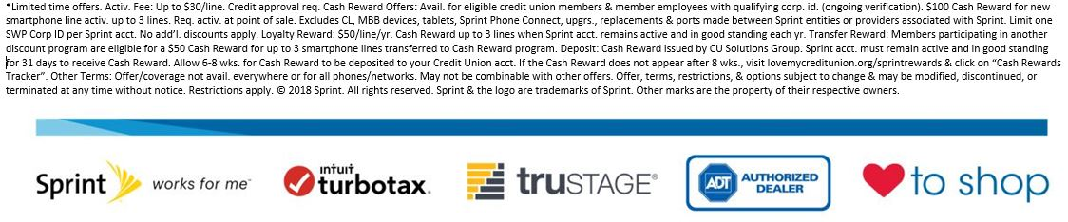
A World of Good Wishes! One of the real joys this holiday season is the opportunity to say THANK YOU and wish you the very best for the new year!!!!!
MERRY CHRISTMAS and HAPPY NEW YEAR from all of us here at NNFCU!!!!!!
STAFF: Becky, Lindsey, Patty, Michelle and Savanna
BOARD OF DIRECTORS: Terry, Bill, Pam, Charlie and Kevin
SUPERVISORY COMMITTEE: Yvonne
CREDIT COMMITTEE: Norb, Larry and Gary
Northeast nebraska federal credit union
1306 North 13th Street Suite 102
Norfolk Ne 68701
(402) 371-9345 www.nnfcu.com
Owned and operated by our membErs for our members

